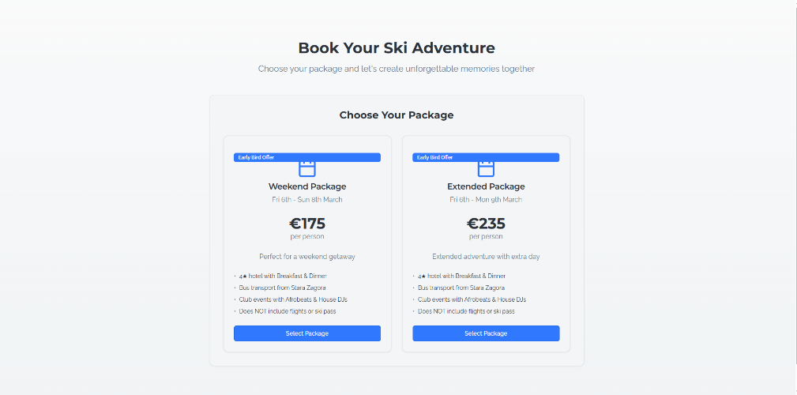 Here you can change weekend package to ‘2 day deal’ and extended package to ‘Full Weekend package’ The prices are also 185 euro and 245euro. Also add ‘airport tranfers available(not included)’ or something like this.

 Here you can change it to ‘Our package includes’

 ‘Bookings’ instead of ‘adventurers’’Experience instead of experiences’This link wasn’t working for me, maybe add more booking links on home page if possible.

 Don’t give specific numbers, Just say Limited places.’6th-9th of March’ instead of ‘March 6-9’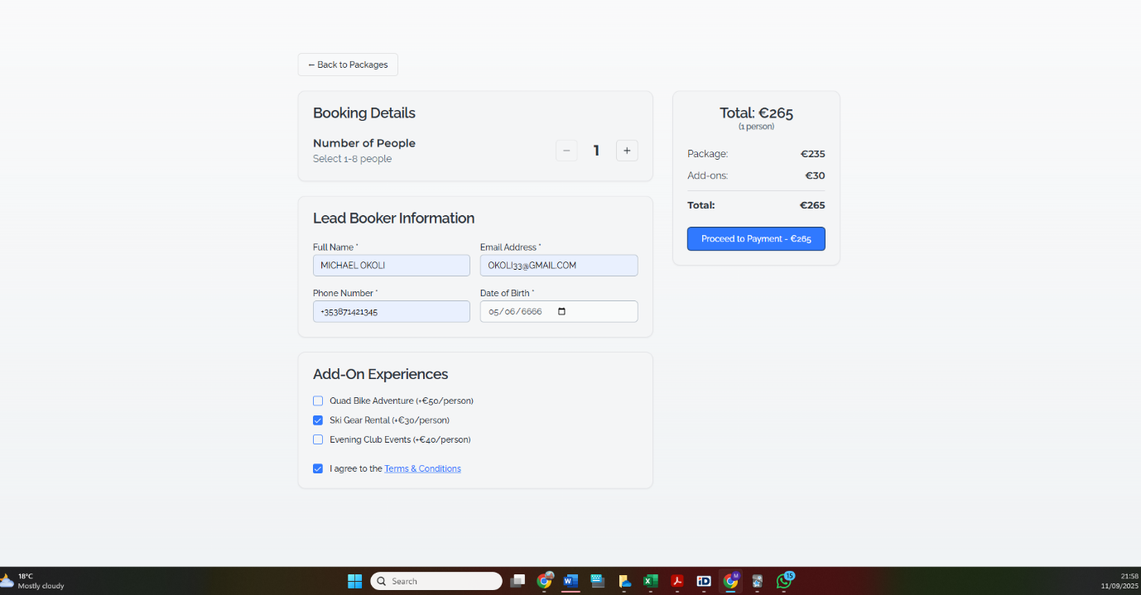Ski gear should be able to be rented per day so under the add on you should be able to specify how many days you want it for etc. And snowboard are a separate booking because they are different price so please keep this in mind. Also the return airport transfers too, ask for flight number etc.. And if they havent booked a flight yet, is there an option to manage their booking? Maybe so they can add ski equipment or ATVs or transfer etc?

Also, you can just add a note that, the rooms are organised in double, 3 people apartments and 5 people apartments so they can have an idea when they add the number of guests they will add. Also if you can add up 15 guests this is perfect because last year we had big group bookings.

Also, evening events are free, so put a 0 there, but they can still book it, this will help us know numbers of people who will go.

 Same thing as above here, just change the format of the date and add ‘places are limited etc’.

Also finally, is it possible to take payments in two installments? We don’t usually charge the full sum up front. They pay a deposit and then the final remainder is paid later in the year maybe January 6th or so.

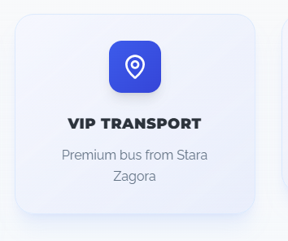Here you can add private transport instead of VIP. The buses aren’t super fancy.

 Group adventures instead of Squad adventures

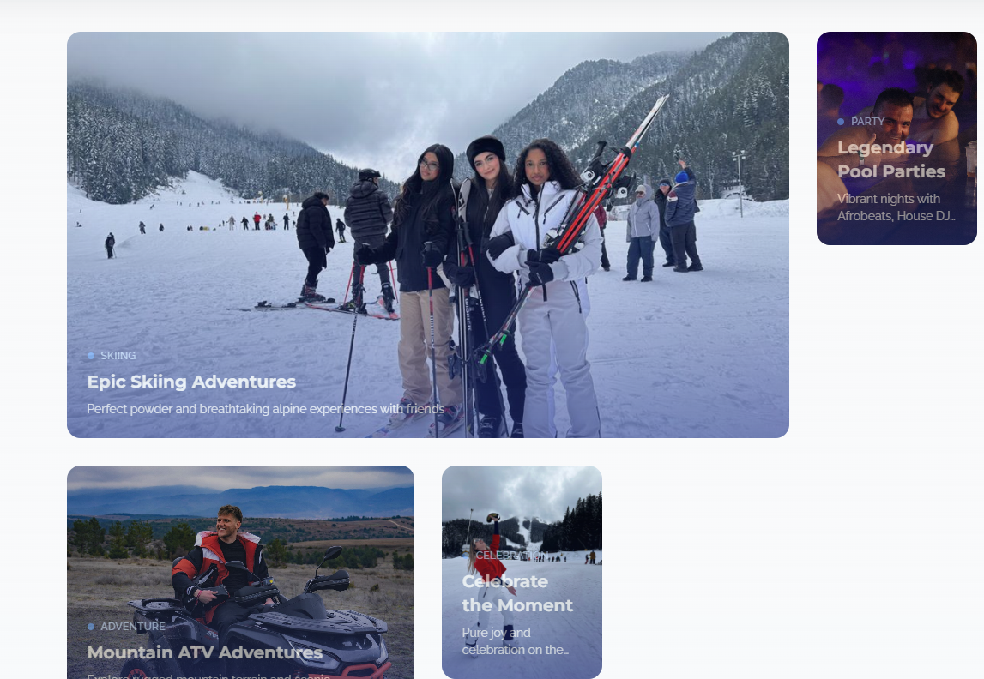Maybe if there was a book now option on all of these images it would be great

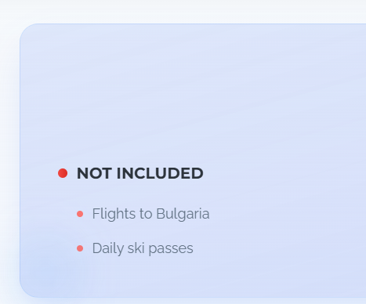Here you can add ‘ whatever is not mentioned under the ‘included’ section. Just to protect us legally.

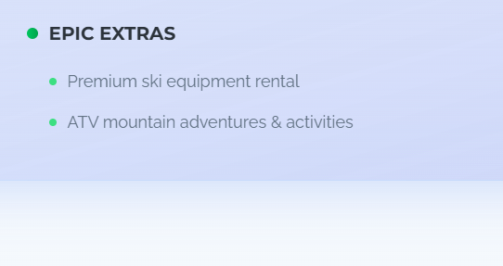Here add ‘discounted rates on Ski rentals’ instead.